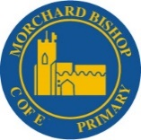
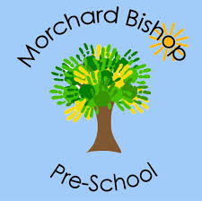

Morchard Bishop C of E Primary School
Morchard Bishop Pre-School

Breakfast & After School Club Booking Form
Child's Name: _______________________________________
Class: ____________________
Breakfast club: £4.00
After school club 1 hour: £4.50 – 2 hours £8.00
Week Beginning: 7th September 2026
Day | Breakfast7:30am–School Start | After School 1 Hour | After School 2 Hours
Monday | ☐ | ☐ | ☐
Tuesday | ☐ | ☐ | ☐
Wednesday | ☐ | ☐ | ☐
Thursday | ☐ | ☐ | ☐
Friday | ☐

Breakfast & After School Club Booking Form
Week Beginning: 14th September 2026
Day | Breakfast7:30am–School Start | After School 1 Hour | After School 2 Hours
Monday | ☐ | ☐ | ☐
Tuesday | ☐ | ☐ | ☐
Wednesday | ☐ | ☐ | ☐
Thursday | ☐ | ☐ | ☐
Friday | ☐

Parent’s Signature: Date:

